WEB DEVELOPMENT

WEDE5020POE

PART 1

**NAME :** JESSICA MMATSHEPO

**SURNAME :** SHAKOANE

**STUDENT NUMBER :** ST10480172

TABLE OF CONTENTS

Table of Contents

Welcome to Bubble sips & sweet smiles 3

BUBBLE SIPS & SWEET SMILE’S MENU : 5

2.1 Website goals 7

2.2 The key performance indicators (KPIs) 7

3. Proposal website features and functionality 7

4. Budget 8

References 9

## Welcome to Bubble sips & sweet smiles

*Unwind with a cup of ecstasy, while brewing moments of delight-ness.*

* Do you have an obsession with bubble tea? Come enjoy a sip of our delightful blends of creamy flavors and escape the ordinary. Fuel your study sessions with a sweet energizing bubble tea. Do you ever feel stressed and overwhelmed due to work or school? We’ve got you covered, visit our corner and enjoy a refreshing pick-me-up with a taste of sweet and bursting flavors, that leave you craving for more. Experience our boba tea from a classic milk tea to tropical fruit blends, we’ve got something for everyone.
* Come and treat yourself to a delightful textural journey, that will make your taste buds sizzling and mothering-watering for more. Craving a sweet escape? Our bubble tea is THE PERFECT SWEET TREAT to satisfy your cravings and the perfect wat to connect, unwind with your friends, while treating yourselves to a moment of pure happiness. As Bubble sips & sweet smiles, we use only the highest quality ingredients, ensuring every sip is a taste of freshness and authenticity. We are a shop that brings bright smiles and we make sure that every customer is left feeling

1. The Organizaton Overview

Bubble tea was established in 1995, in the province of Cape town in V&A Waterfront-bay. Bubble tea is a tea-based drink most often containing chewy, sweet, tropical fruit blends and delicious flavoring. Bubble tea is also known as ***boba tea***. Bubble tea is most commonly made with tapioca pearls (also known as “boba” or “balls”). Experience the discovery of the joy that comes from the chewy tapioca pearls (boba) in every sip. The tapioca pearls (boba) are the signature element of our bubble tea creations. We have many varieties and different kinds of flavors, but our most popular varieties are **pearls black milk tea** and **pearl green milk tea**. We have the finest tea in the world, it’s inspiring and it nurtures the human spirit. One of the biggest draws of boba tea is the ability to customize it according to your own liking, from the type of favorite tea and sweetness levels to a variety of toppings to choose from. This customization makes every cup unique and enjoying every moment to the last sip. Bubble tea is perfect for a quick pick-me-up or delightful treat with friends and family. Due to popularity, bubble tea has inspired a variety of bubble tea flavourable snacks, such as bubble **ice cream** and bubble **tea candy**. Even today bubble tea continues to evolve, with new flavors and varieties constantly being introduced, and it remains a popular beverage worldwide. This is one of our favored bubble tea, that most of our customer buy more. It is definitely recommended and you will never regret yourself for purchase it.

(Ha, n.d.)

SALTED CARAMEL FRAPPUCINO BOBA TEA

# BUBBLE SIPS & SWEET SMILE’S MENU :

(whitewish, 2015)

Bubble-gum hibiscus milk bubble tea

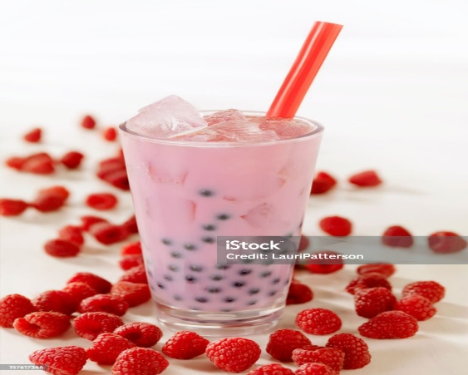 (LauriPatterson, 2010)

Raspberry bubble tea

(Preciado, 2021)

Classic Chocolate boba tea

(Cruz, n.d.)

Golden brown amber boba tea

(Coa. Y,2023)

Matcha bliss boba tea

2.WEBSITE GOALS AND OBJECTIVES:

## 2.1 Website goals

* Bubble tea’s mission statement is ***“To deliver happiness, one cup at a time, by creating a unique and a warm welcoming environment where our customers can enjoy authentic, classic bubble tea that is crafted with love and care. “*** . Bubble tea aims to provide customers with a unique and enjoyable beverage experience, focusing on quality ingredients and innovative flavors. We aim to be a destination, offering more than just a drink, but a memorable experience. As bubble sips & sweet smiles, we want to be a place that people choose to visit and enjoy, not just a quick shop for a drink. At our bubble tea shops, we envision everyone gathered over savory unique flavors, and creating long lasting memories. We aim to create an inviting and comfortable atmosphere, where customers can relax, unwind, and enjoy the moment. We aim to make every visit a sensory journey for the customers, from the moment they walk through the doors, to the last sip of their favorite bubble tea. Ensuring that every moment is valued and appreciated.

## 2.2 The key performance indicators (KPIs)

* Moderate check size
* Column time
* Customer maintenance estimate
* Toil cost percentage

## 3. Proposal website features and functionality

* Home page : The home page is the primary web page of the website. It functions as a navigation to a website, as a landing page to draw visitors.
* About us : The about us page is used to provide customers more insight into what the business does and the history of it. It provides info about the business.
* Contact page: The contact page is the web page for visitors to contact the business.
* Products page : The product page is a component of an online store. It provides info about the products that the business sells.
* Enquiry page: The web page that allows customers inquire about their products and services on their website.

## 4. Budget

* The budget for development, hosting, and maintenance for website is R19 000

# References

Cao, Y. (2023, October 18). *Pixel images*. Retrieved April 4, 2025, from https://www.pexels.com/search/green%20matcha%20boba%20tea/

Cruz, K. (n.d.). *Pixel images*. Retrieved march 31, 2025, from https://www.pexels.com/photo/clear-plastic-cup-with-brown-liquid-and-ice-4071422/

Ha, N. B. (n.d.). *pixels images*. Retrieved 31 March, 2025, from https://www.pexels.com/photo/close-up-photo-of-a-plastic-cup-with-milk-tea-12187693/

LauriPatterson. (2010, June 15). *Pixel images*. Retrieved April 4, 2025, from https://www.istockphoto.com/photo/raspberry-bubble-tea-gm157617346-13278239?utm_source=pexels&utm_medium=affiliate&utm_campaign=sponsored_photo&utm_content=srp_inline_media&utm_term=rasberry%20bubble%20tea

Preciado, A. (2021, August 7). *Pixels images*. Retrieved April 4, 2025, from https://www.pexels.com/photo/drink-in-a-glass-8911656/

Sheykin, H. (2025, April 5). *FINMODELSLAB*. Retrieved April 7, 2025, from finmodelslab.com/blogs/kpi-metrics/cafe

*What is an about us page? - BigCommerce*. (n.d.). Retrieved April 7, 2025, from https;//www.bigcommerce.com

whitewish. (2015, November 18). *Pixel images*. Retrieved April 4, 2025, from https://www.istockphoto.com/photo/taro-bubble-tea-gm497654828-74703415?utm_source=pexels&utm_medium=affiliate&utm_campaign=sponsored_photo&utm_content=srp_inline_media&utm_term=rasberry%20bubble%20tea

*Wikipedia*. (2025, February 7). Retrieved April 7, 2025, from en.m.wikipedia.org

*Wikipedia*. (2025, february 7). Retrieved from https;//en.wikipedia.org

*WIKIPEDIA*. (2025, february 7). Retrieved April 7, 2025, from https://en.wikipedia.org

[19 Best Product Page Design Examples for Inspiration in 2025 - Shopify](https://www.shopify.com/blog/product-page)

https://instapage.com/en/template/effective-inquiry-page-template[Effective inquiry page template | Instapage](https://instapage.com/en/template/effective-inquiry-page-template)